**India’s Agricultural Crop Production Analysis (1997-2021)**

**1. INTRODUCTION**

**1.1 Overview**

This report delves into the captivating realm of India's agricultural cultivation, providing a comprehensive visual exploration of key aspects and trends in the agricultural sector. Through the visual representations, readers can gain valuable insights into crop production, seasonal variations, regional distribution, and overall production trends. These visualizations enable intuitive analysis, allowing stakeholders to uncover patterns, identify areas of growth or concern, and make data-driven decisions. By harnessing the power of Tableau, this report not only presents the data in a visually appealing manner but also provides an interactive experience for readers to explore the intricacies of India's agricultural cultivation. To Extract the Insights from the data and put the data in the form of visualizations, Dashboards and Story we employed Tableau tool.

**1.2 Purpose**

India is the second-most populous country in the world. And to feed such a huge population, there is always a constant need for a supply of food. Therefore, there is a need for agriculture and a need for less dependency on the agriculture sector for the Economy.

**2. Problem definition and design thinking**

**A. Empathy Map**

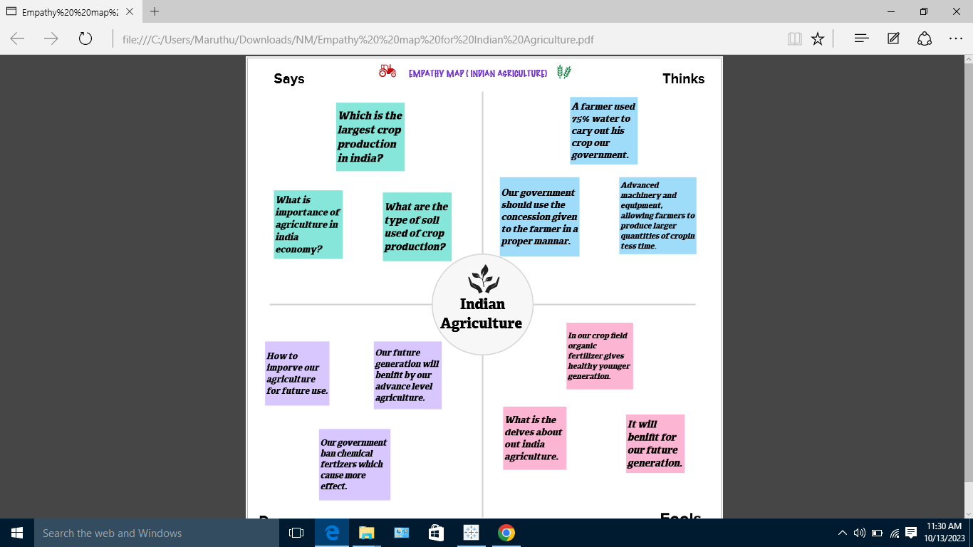

**2.2 Ideation and Brainstroming Map**

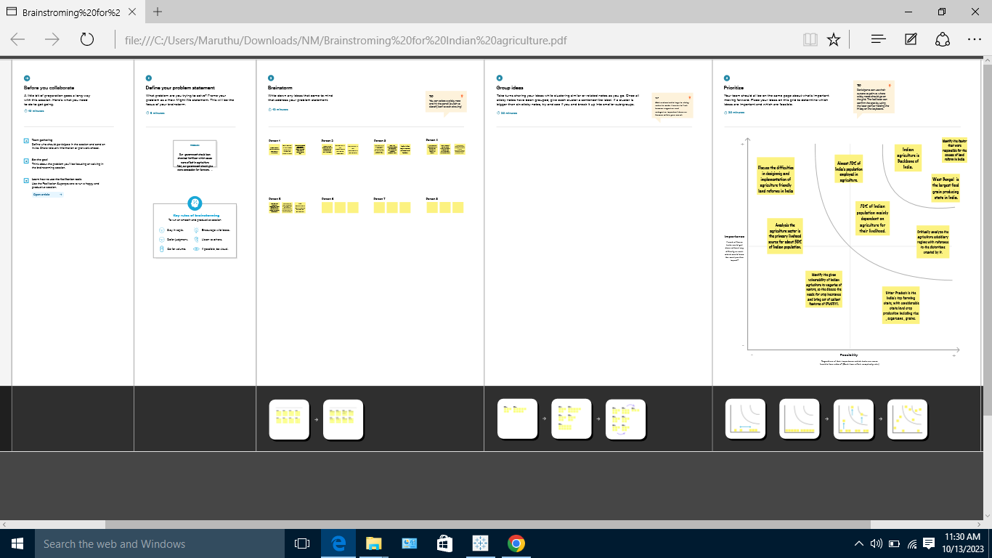

**3. RESULT (project along with screenshot)**

Area vs production

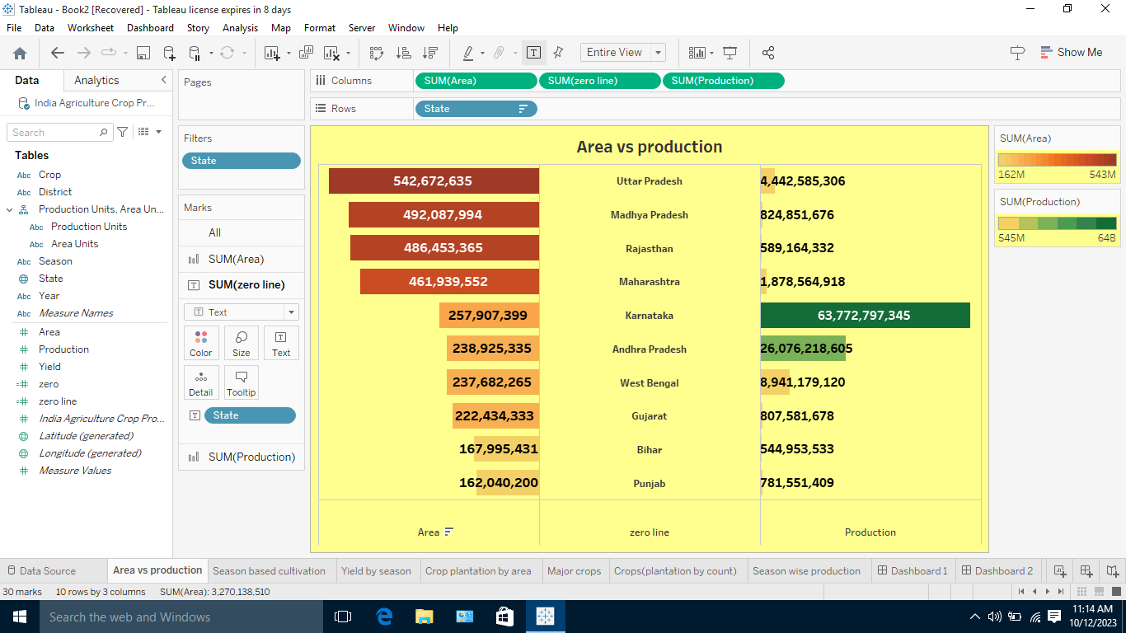

Season based production

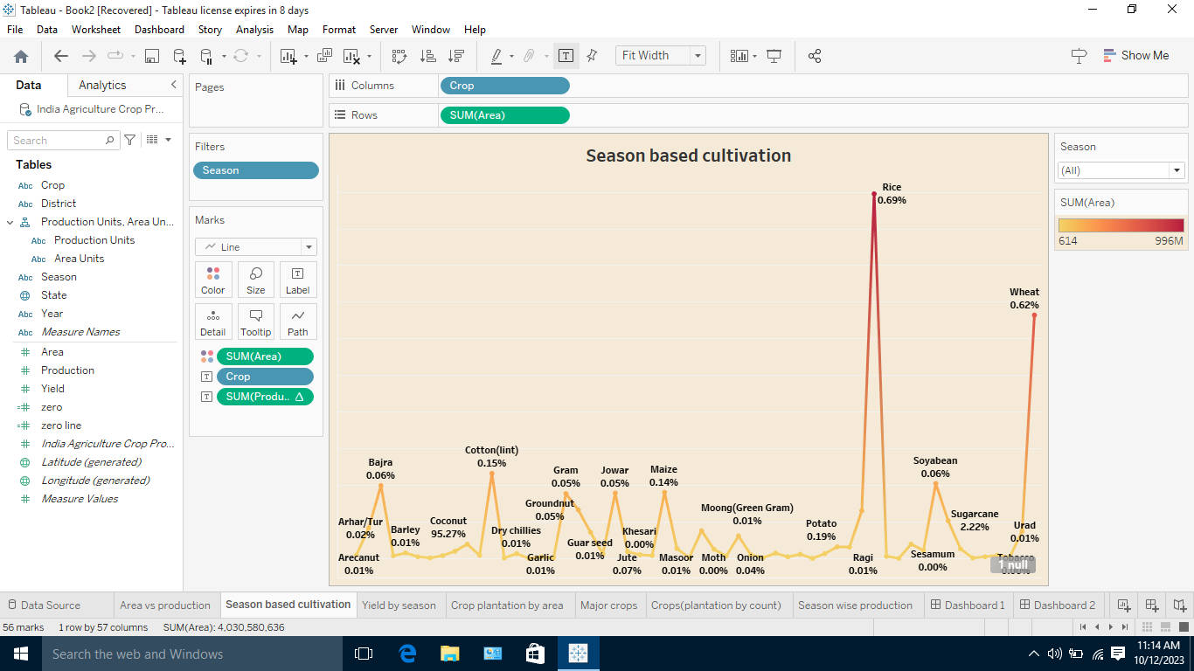

Yield by season

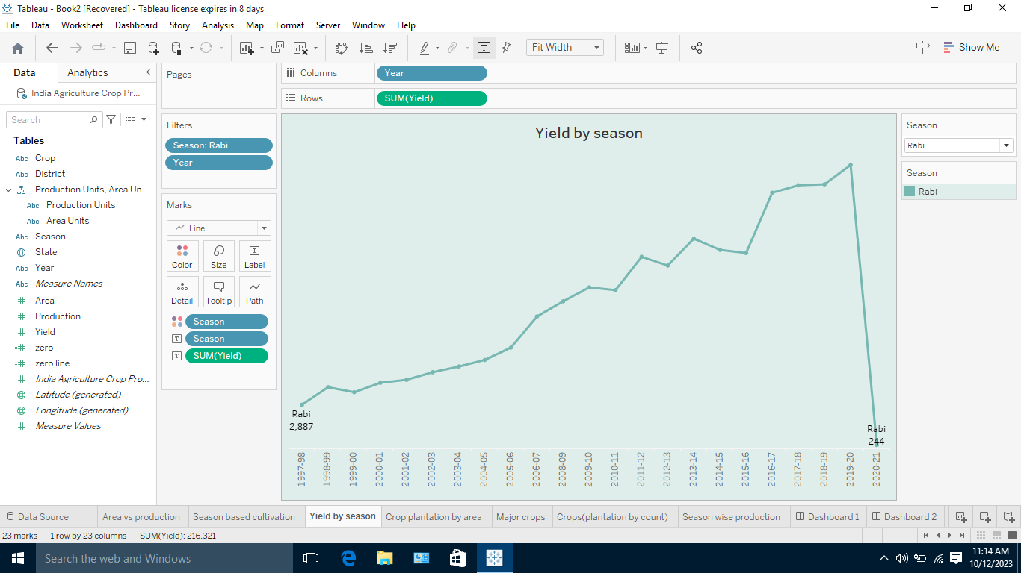

Major crops

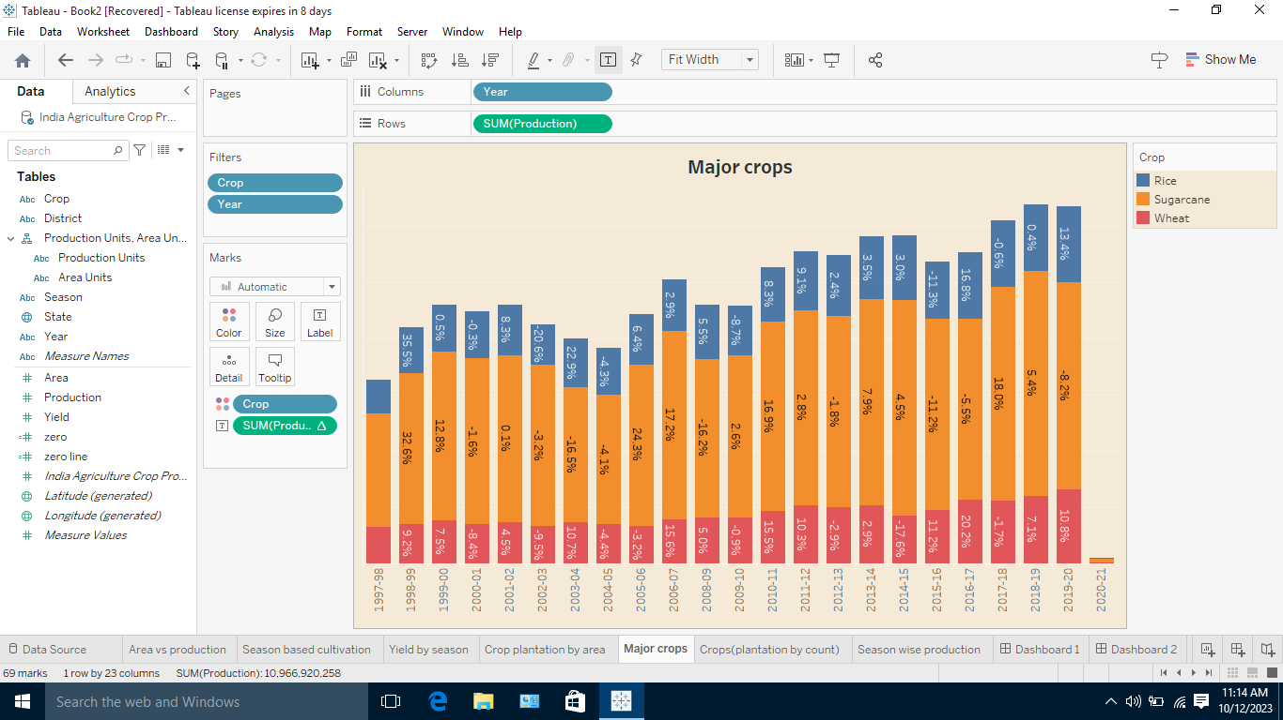

Crop plantation by area

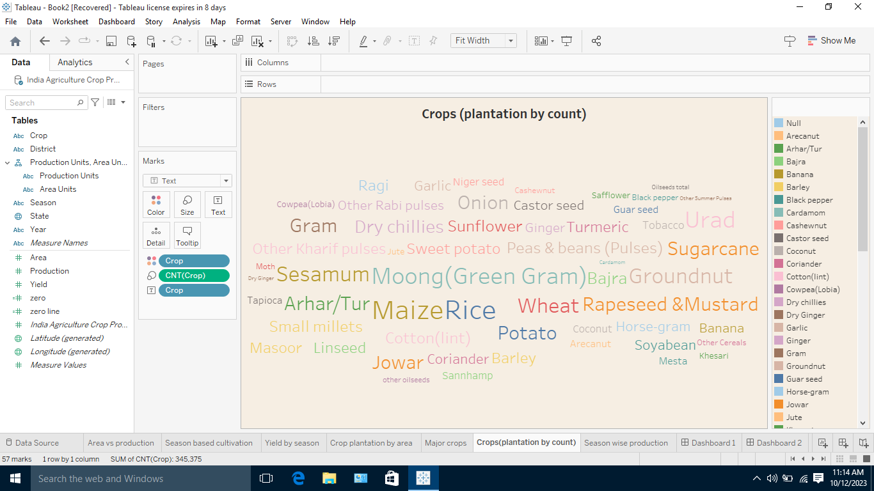

Season wise production:

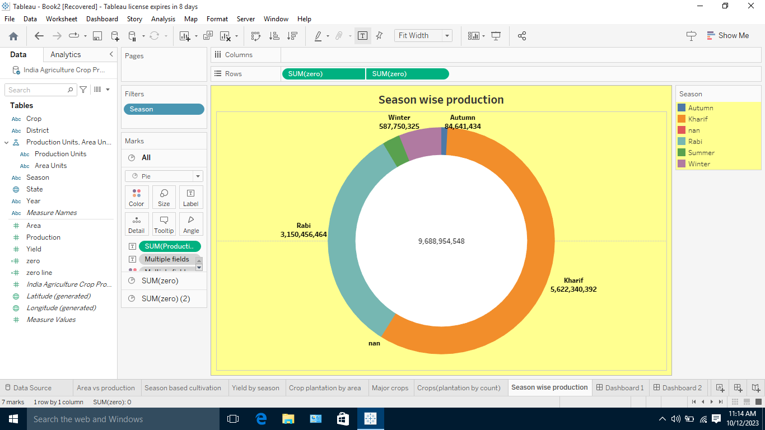

Dashboard 1:

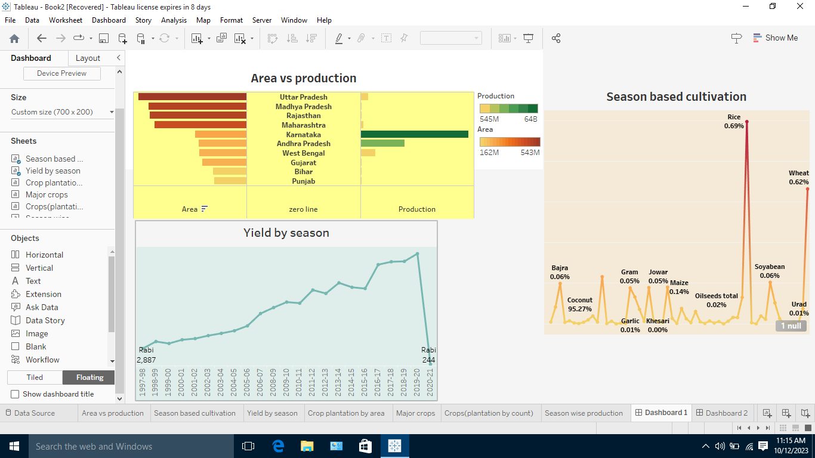

Dashboard 2

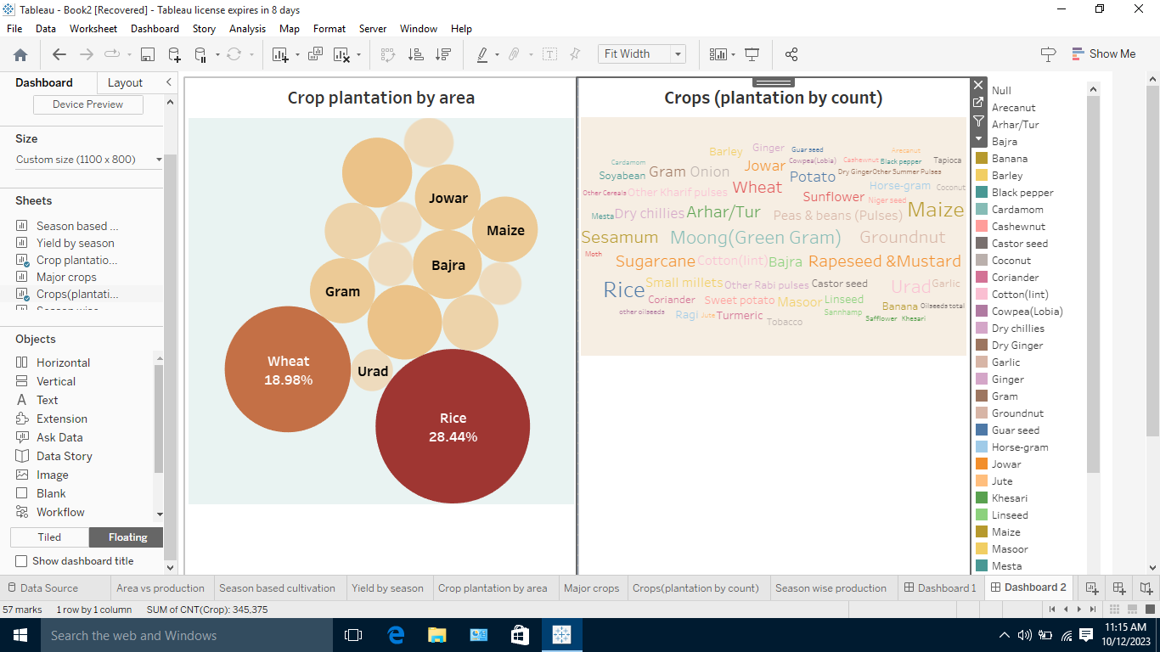

Dashboard 3

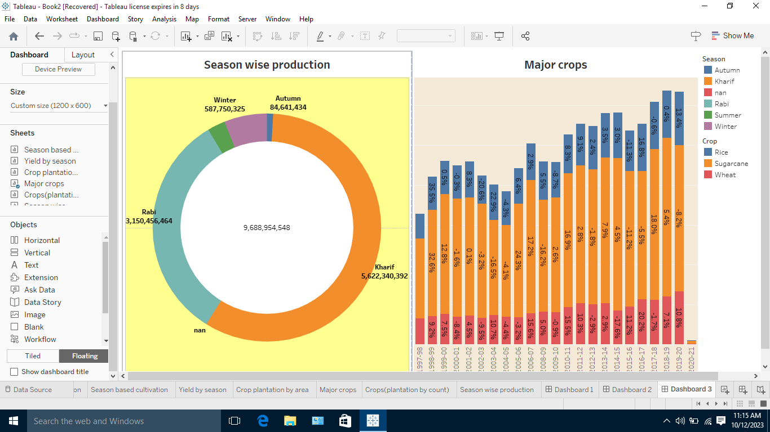

Story 1:

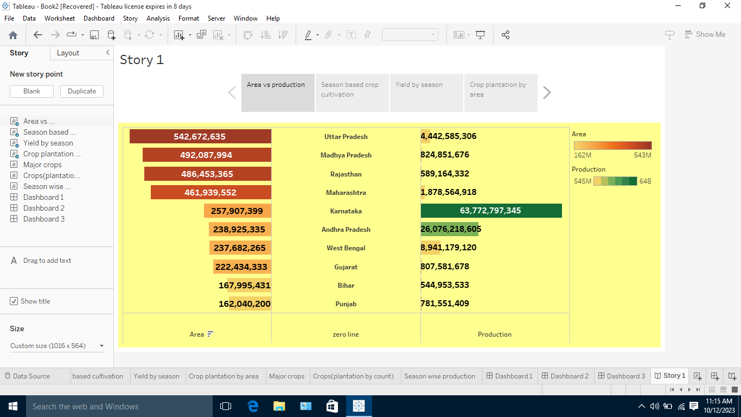

Story 2:

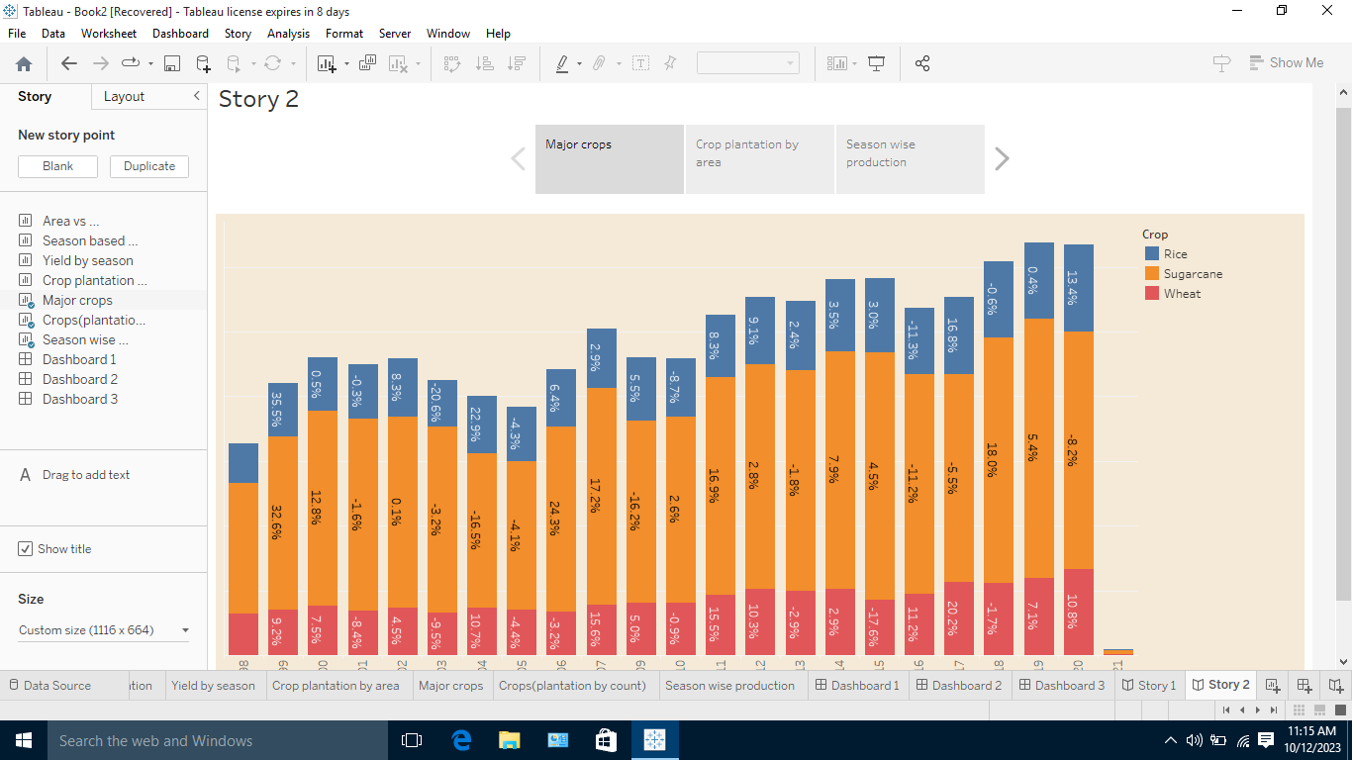

RESULT ;

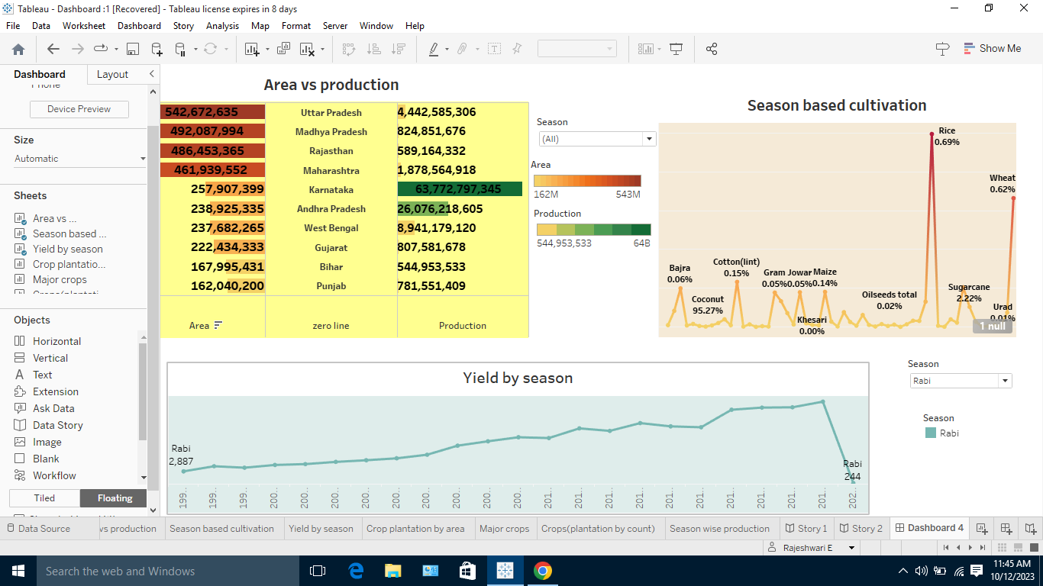

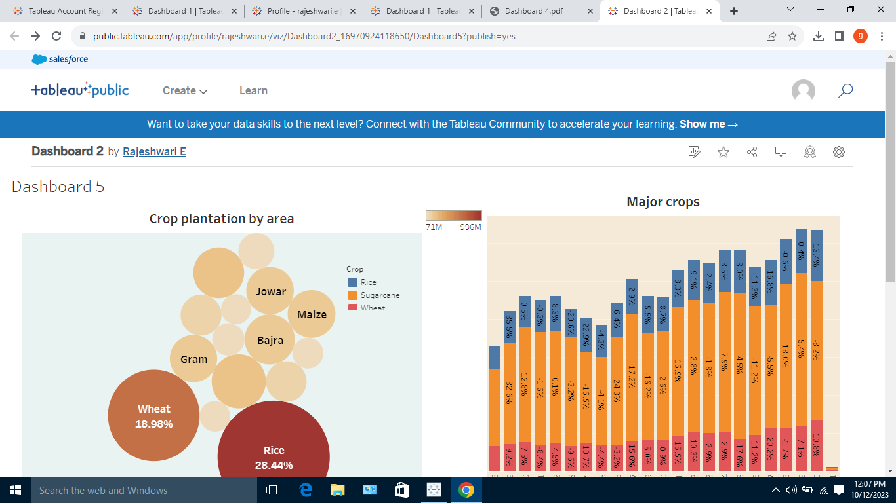

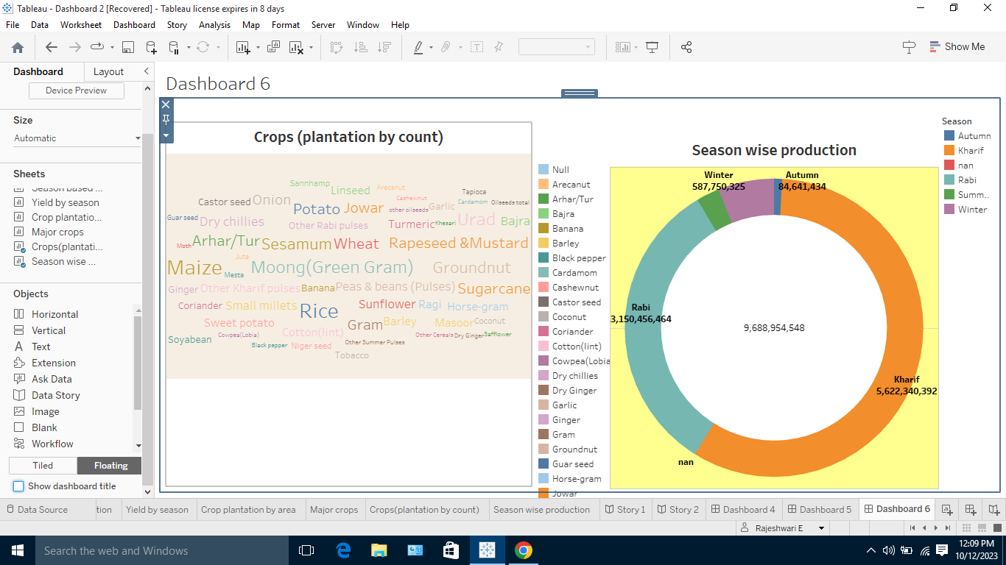

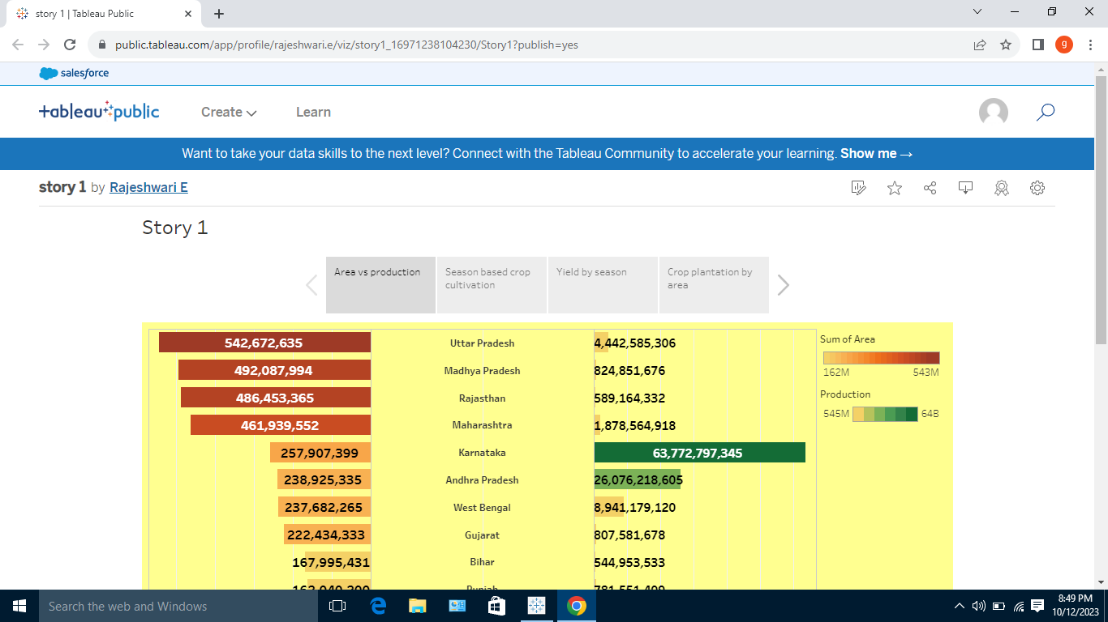

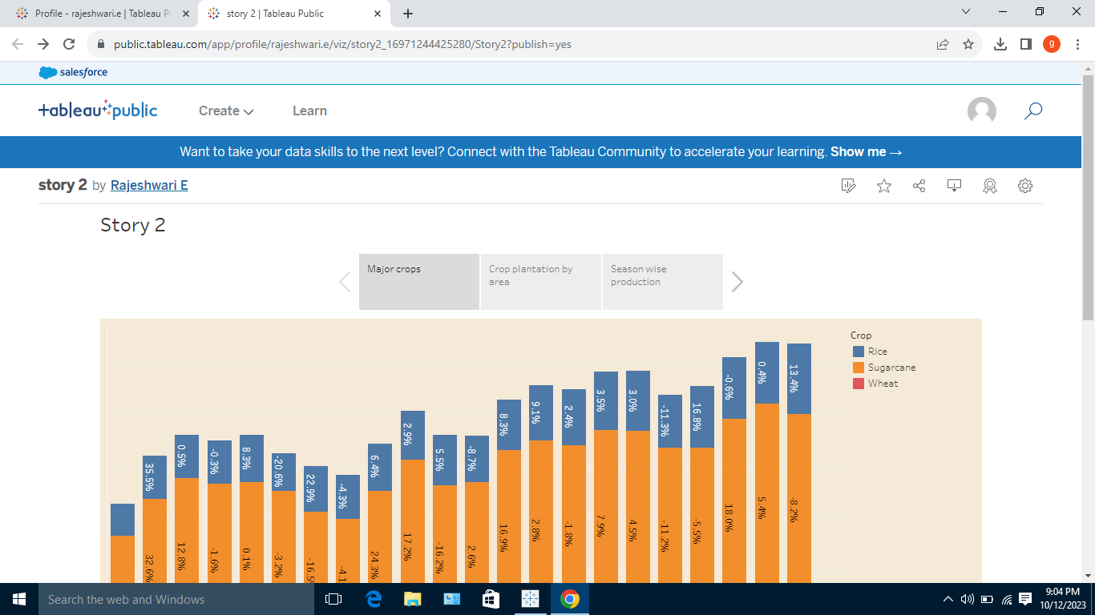

4**. ADVANTAGE OF THE PROPOSED SOLUTION**

ADVANTAGE

* The prominent advantage of the proposed the solution are techniques which are less time and money consuming compare to numeral and experimental method
* Easy to swallow ,especially for periodic and geriatric patients
* The combination of the properties of a series AC voltage compensator and phase shifters without DC energy storage
* The fact that it has an analytic simple expression making its implementation complexity very low
* Limitation of the purposed solution of discussed in the context of available fabrication techniques

**APPLICATION**

**Five ways to reduce farm distress in India**

* Increasing incomes. Agricultural transformation is very slow in India. ...
* Generating employment opportunities. ...
* Reducing risks in agriculture. ...
* Developing agri-infrastructure. ...
* Improving quality of rural life.

**5. CONCLUSION**

The Indian economy is an agro-economy and depends highly on the agricultural sector. Despite just supporting the Indian Economy, the agricultural sector also supports the industrial sector and international trade in imports and exports.

**6. FUTURE SCOPE**

**Some measures that will help boost agricultural development in India.**

* Efficient markets.
* Irrigation augmentation and management.
* Agri-credit and crop insurance.
* Adoption of new technologies.
* Enhancement of soil quality.

Indian agriculture can help the nation tackle three of its biggest challenges — feeding a huge and expanding population, ensuring sufficient energy supplies and curbing emissions. Still, meeting these goals will require a coordinated effort with alignment across policy, investment and agricultural research.